Software Architecture Document

**Polymer Chemistry Design**

A web-based system for Polymer Chemistry researchers.

**Context**

The Polymer Chemistry upload system allows researchers to upload and share their polymer

research with other researchers globally. This service is more targeted towards researchers at

universities and companies who work on polymer data. New research can potentially be done if

other researchers gain access to the research of other researchers. This data can then be filtered

by certain constraints to match whatever researchers are looking for.

**Architecture Overview**

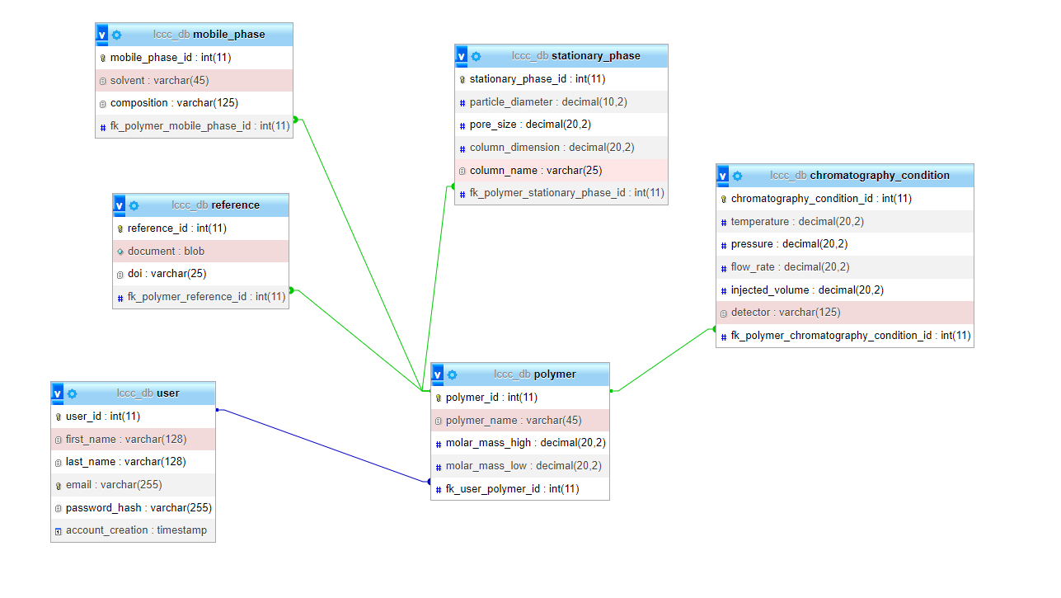

**Stakeholders**

* Researchers uploading data
* Users who take data and do what they want with it

**Languages Used**

* HTML
* PHP
* CSS
* JavaScript

**Components**

* Frontend
  + HTML
  + CSS
  + jQuery
  + JustValidate
* Backend
  + PhpMyAdmin (SQL)
  + PHP

**FrontEnd**

Listens on http/https port 8080

Makes use of the POST and GET methods to send and retrieve data to and from other pages.

**BackEnd**

Listens on port 3306

This component handles the request being made and to the database.

**Implementation**

Polymer Chemistry Research uses HTML and CSS for the placement and visualization of the form pages, SQL for backend database and jQuery and JustValidate for the validation of those pages. PHP was also used to connect all of these pages and provide more security and validation.